PRAKTIKUM BASIS DATA

MODUL 6
06_Scripting_Subquery

Oleh:

Haryanto Wifakul Azmi 103122400037

PROGRAM STUDI S1 REKAYASA PERANGKAT LUNAK
DIREKTORAT KAMPUS PURWOKERTO
UNIVERSITAS TELKOM
2026
TP

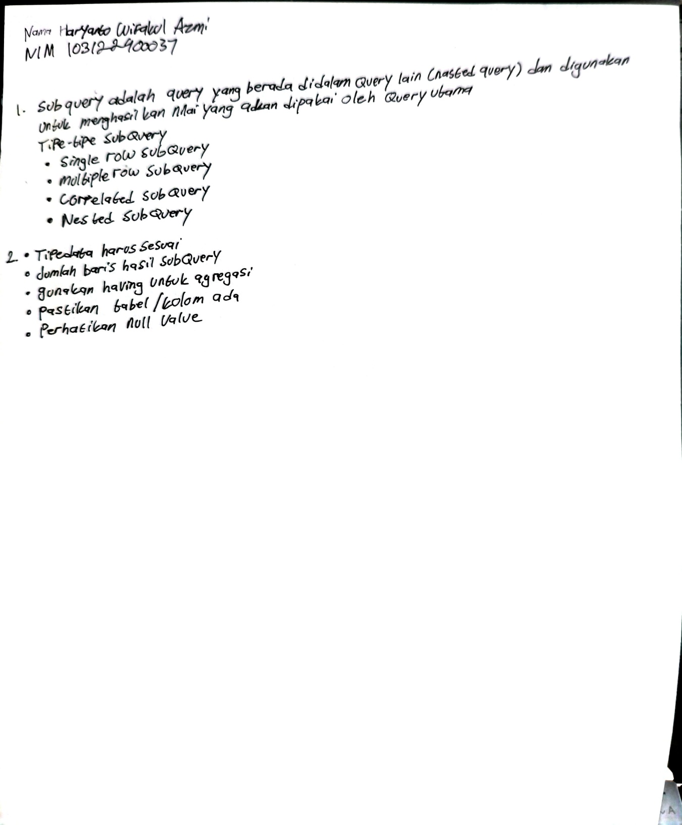

- Buatlah subquery untuk menampilkan judul film dengan durasi terpendek dan umur termuda yang menonton film tersebut . (SS Output)
Jawaban:
Query:
SELECT f."JUDUL",
MIN(TRUNC(MONTHS_BETWEEN(SYSDATE, m."TGL_LAHIR")/12)) AS UMUR_TERENDAH
FROM "FILM" f
JOIN "JADWAL" j ON f."ID_FILM" = j."ID_FILM"
JOIN "TRANSAKSI" t ON j."ID_JADWAL" = t."ID_JADWAL"
JOIN "MEMBER" m ON t."ID_MEMBER" = m."ID_MEMBER"
WHERE f."DURASI" = (
SELECT MIN("DURASI")
FROM "FILM"
)
GROUP BY f."JUDUL";
Output:
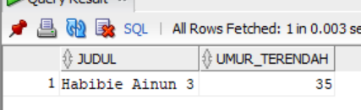

- Buatlah subquery untuk menampilkan nomor teater, kelas, dan total pemakaian teater tersebut yang paling sering digunakan dengan menggunakan Join on. (SS Output)
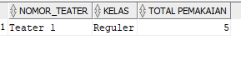
Jawaban
Query:
SELECT th."ID_THEATER", th."KELAS", COUNT(*) AS TOTAL_PAKAI
FROM "THEATER" th
JOIN "JADWAL" j ON th."ID_THEATER" = j."ID_THEATER"
JOIN "TRANSAKSI" t ON j."ID_JADWAL" = t."ID_JADWAL"
GROUP BY th."ID_THEATER", th."KELAS"
HAVING COUNT(*) = (
SELECT MAX(jumlah)
FROM (
SELECT COUNT(*) AS jumlah
FROM "JADWAL" j2
JOIN "TRANSAKSI" t2 ON j2."ID_JADWAL" = t2."ID_JADWAL"
GROUP BY j2."ID_THEATER"
)
);
Output :
